SmartBudget Application – Final Project Documentation

Student: Caige Laurenti  
Course: SDEV 200  
Instructor: Timothy Newell  
Date: 10/18/2025

# 1. Application Overview

The SmartBudget application is a JavaFX-based desktop program that allows users to track, manage, and visualize their financial activity. The user interface includes a Home screen, a Transactions screen for adding and managing records, and a Reports screen that displays charts of income and expenses. Data persistence is handled through a simple CSV file, ensuring that user transactions are saved between sessions.

# 2. UML Diagram

The following UML diagram shows the key classes and their relationships in the SmartBudget application:

+----------------------+   
| Main |   
|----------------------|   
| + start(Stage) |  
| | |  
+----------------------+   
 |  
 v  
+----------------------+  
| HomeController |  
|----------------------|  
| + gotoTransactions() |  
| + gotoReports() |  
+----------------------+  
 |  
 v  
+----------------------+  
| Controller |  
|----------------------|  
| + add() |  
| + deleteSelected() |  
| + saveFile() |  
+----------------------+  
 |  
 v  
+----------------------+  
| ReportController |  
|----------------------|  
| + initialize() |  
| + goHome() |  
+----------------------+  
  
+----------------------+  
| TransactionManager |  
|----------------------|  
| - data: List |  
| + add() |  
| + delete() |  
| + save() |  
+----------------------+  
 |  
 v  
+----------------------+  
| Transaction |  
|----------------------|  
| - id:int |  
| - date:String |  
| - amount:double |  
| - category:String |  
| - description:String |  
| - type:String |  
+----------------------+  
  
+----------------------+  
| FileUtils |  
|----------------------|  
| + load(File) |  
| + save(File) |  
+----------------------+

# 3. Screenshots and Testing Evidence

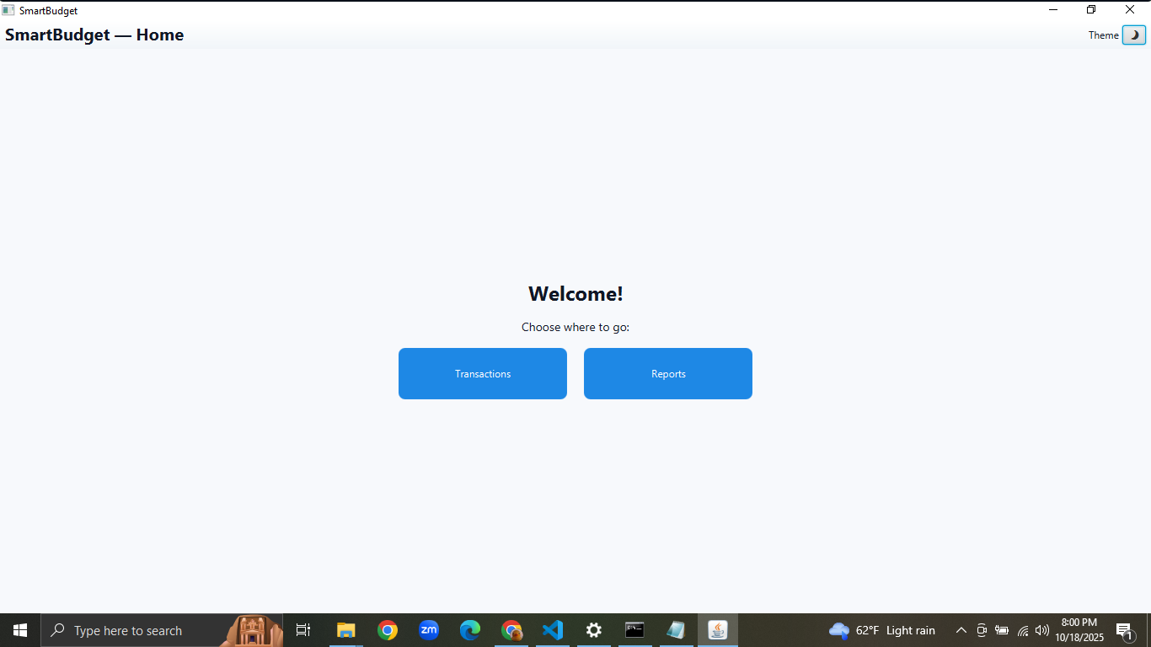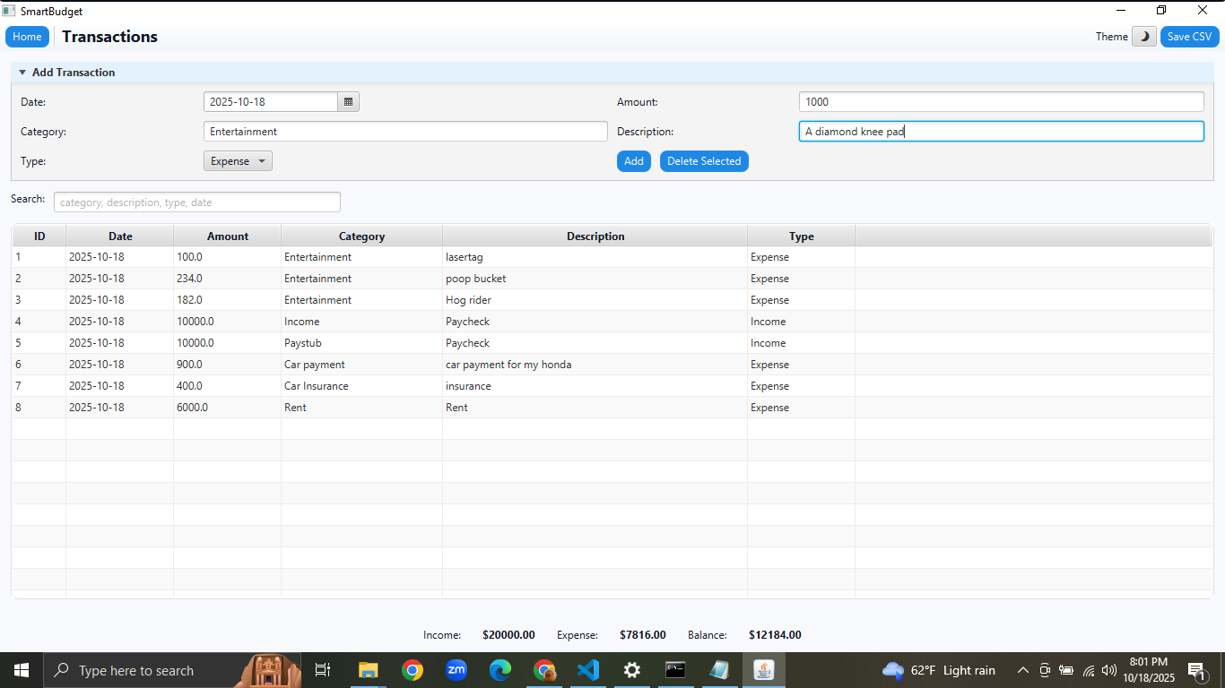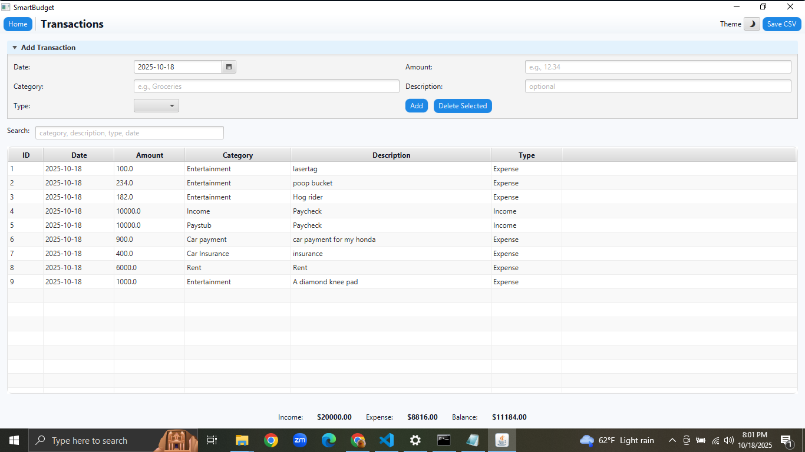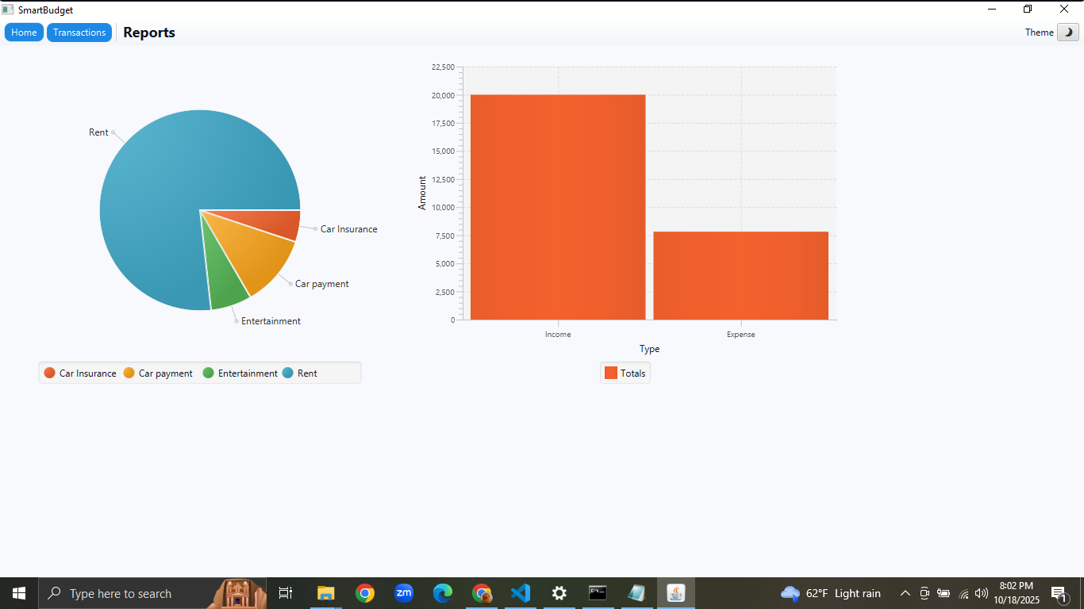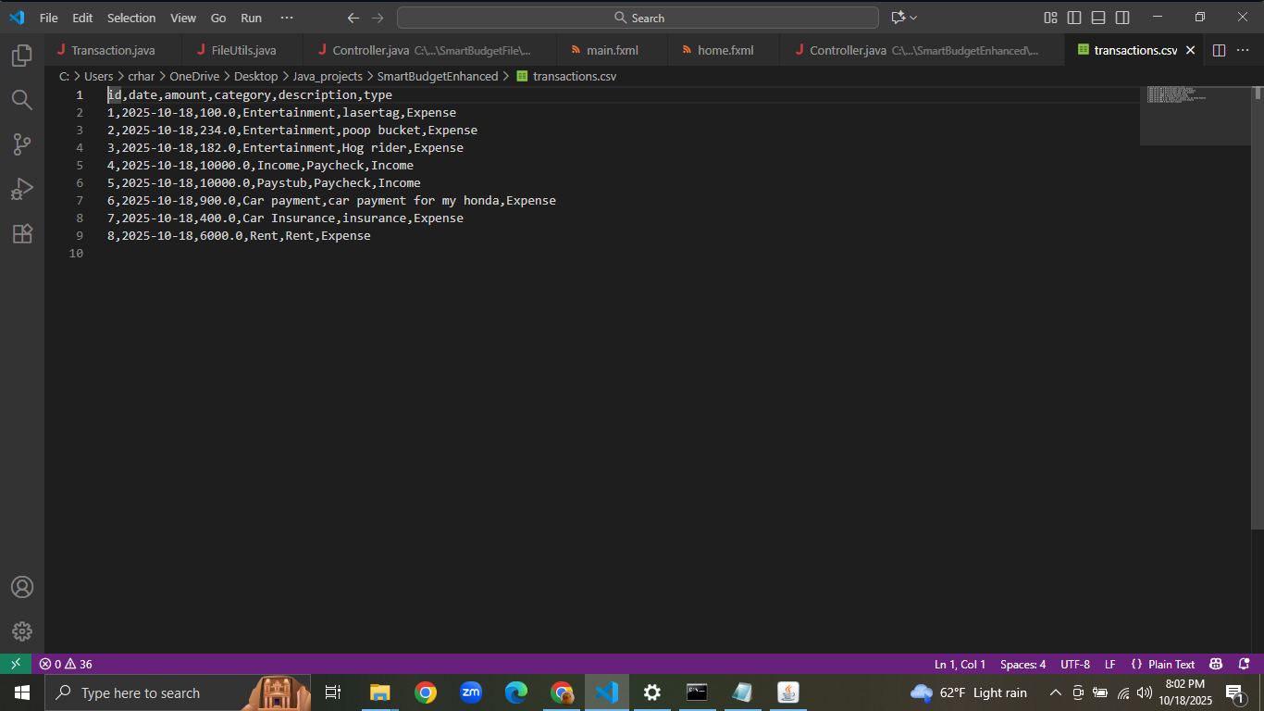

# 4. Test Summary

All features were tested to ensure full functionality. Navigation between pages works correctly, transaction records can be added and deleted, data saves properly to the CSV file, and reports update dynamically. Input validation prevents errors such as empty fields or invalid numbers.

# 5. Conclusion

The SmartBudget application demonstrates the use of JavaFX for building interactive graphical programs, object-oriented design through MVC architecture, and file-based data storage. The project successfully allows users to track and visualize financial transactions in an intuitive way. Future enhancements could include sorting, date filtering, and integration with online data sources.